Team2

UseCase Diagrams

Organocity

Customer UseCase Diagram

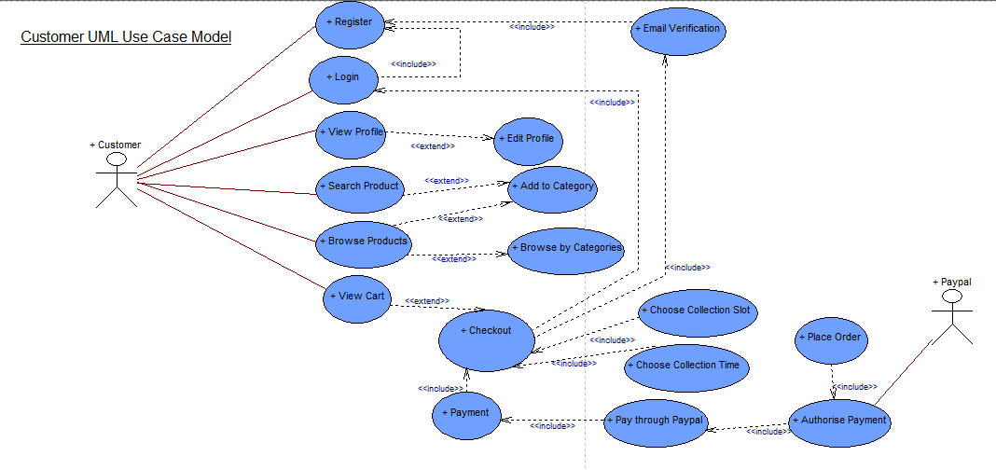

Trader UseCase Diagram

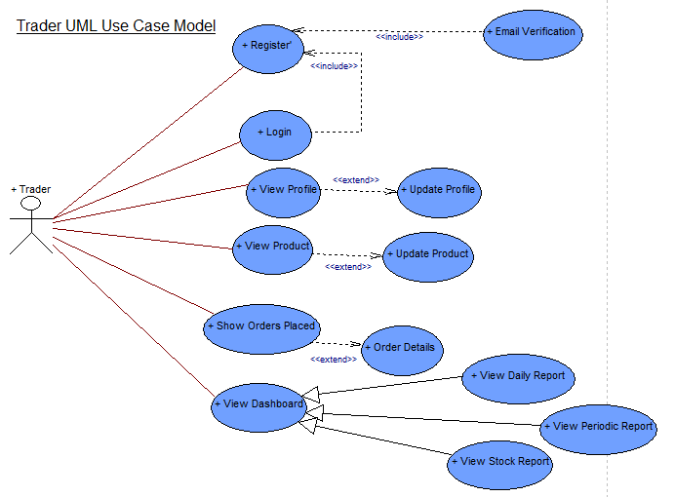

Administrator UseCase Diagram

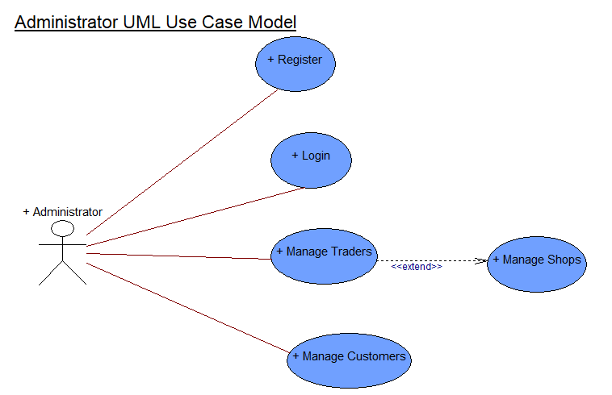

Overview UseCase Diagram

